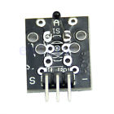

# **Hot Temperature Sensor AVR PIC Analog Module For Arduino**

* 100% brand new and high quality
* Module introduces
* The module is based on the thermistor (resistance increases with the ambient temperature
* changes) works, a sense of real-time to know the temperature of the surrounding environment changes, we send the data to the Arduino analog IO, then come down as long as we go through simple programming will be able to convert the sensor output data Celsius temperature values and displayed, it is still easy to use,It effectively, thereby widely used in gardening, home alarm systems and other devices.
* Method of application
* And the general temperature sensor is the same, are three-line package, when we use the power cord connected OK signal output into the end on the line, because the module output is an analog signal, we want to signal output terminal connected to the Arduino analog IO on sampling, so as to correctly read the temperature value

Connect method

* + connect 5V
* S connect signal
* - connect GND
* 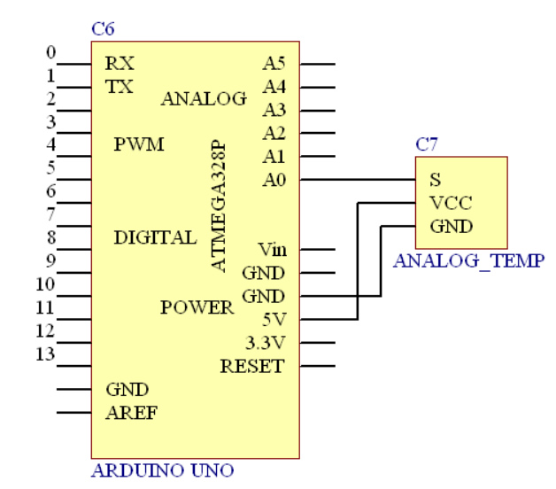

Test Code：

#include <math.h>

double Thermister(int RawADC) {

double Temp;

Temp = log(((10240000/RawADC) - 10000));

Temp = 1 / (0.001129148 + (0.000234125 + (0.0000000876741 * Temp * Temp ))* Temp );

Temp = Temp - 273.15;// Convert Kelvin to Celcius

return Temp;

}

void setup() {

Serial.begin(9600);

}

void loop() {

Serial.print(Thermister(analogRead(0)));

Serial.println("c");

delay(500);